CIA -1

package cia1;

import org.openqa.selenium.By;

import org.openqa.selenium.WebDriver;

import org.openqa.selenium.WebElement;

import org.openqa.selenium.chrome.ChromeDriver;

import org.openqa.selenium.chrome.ChromeOptions;

public class Q1 {

public static void main(String[] args) throws InterruptedException

{

System.setProperty("webdriver.chrome.driver","C:\\ChromeDriver\\chromedriver.exe");

WebDriver driver;

ChromeOptions co=new ChromeOptions();

co.addArguments("--remote-allow-origins=*");

driver=new ChromeDriver(co);

driver.navigate().to("https://www.amazon.in/Apple-iPhone-14-512GB-Purple/dp/B0BDJYHP2H/ref=sr_1_1_sspa?keywords=iphone+14&qid=1681288324&sprefix=iphon%2Caps%2C587&sr=8-1-spons&sp_csd=d2lkZ2V0TmFtZT1zcF9hdGY&psc=1");

driver.manage().window().maximize();

WebElement addtocart=driver.findElement(By.id("add-to-cart-button"));

addtocart.click();

Thread.sleep(5000);

WebElement cartbutton=driver.findElement(By.xpath("//*[@id=\"attach-sidesheet-view-cart-button\"]/span/input"));

cartbutton.click();

Thread.sleep(5000);

WebElement qty= driver.findElement(By.id("a-autoid-0-announce"));

qty.click();

Thread.sleep(5000);

WebElement proceedtobuy=driver.findElement(By.name("proceedToRetailCheckout"));

proceedtobuy.click();

System.out.print("Checked out Sucessfully");

}

}

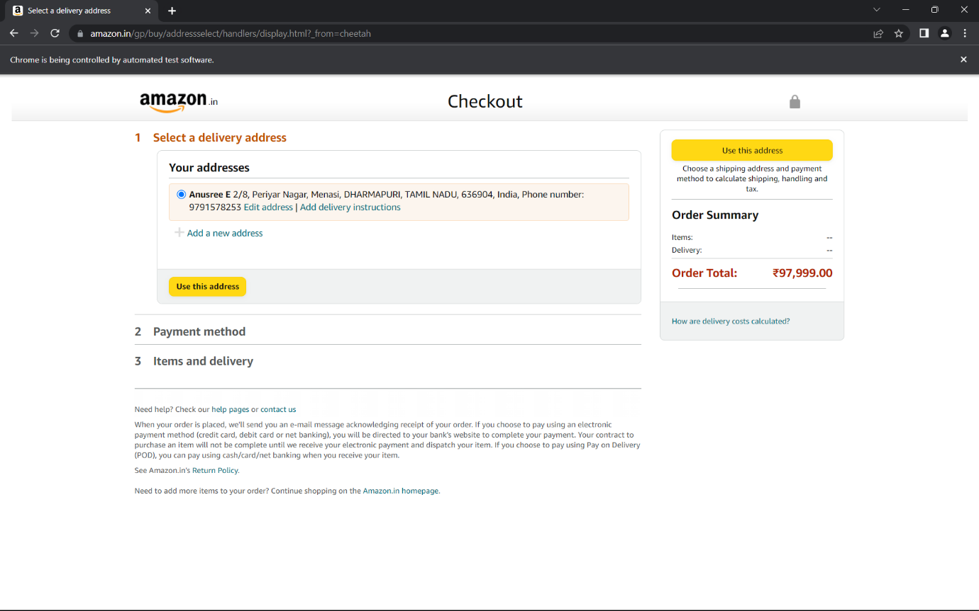

2.

package cia1;

import java.util.ArrayList;

import org.openqa.selenium.By;

import org.openqa.selenium.WebDriver;

import org.openqa.selenium.WebElement;

import org.openqa.selenium.chrome.ChromeDriver;

import org.openqa.selenium.chrome.ChromeOptions;

public class Q2 {

public static void main(String[] args) {

System.setProperty("webdriver.chrome.driver","C:\\ChromeDriver\\chromedriver.exe");

ChromeOptions co=new ChromeOptions();

co.addArguments ("--remote-allow-origins=*");

WebDriver driver=new ChromeDriver(co);

driver.get ("https://www.amazon.in/");

driver.manage().window().maximize() ;

String currentTitle=driver.getTitle();

System.out.println(currentTitle);

String expectedTitle="Online Shopping site in India: Shop Online for Mobiles, Books, Watches, Shoes and More - Amazon.in";

if(currentTitle.equals(expectedTitle)) {

System.out.println("Title Matched");

}

else {

System.out.println("Title not Matched");

}

WebElement txtBoxl=driver.findElement(By.xpath("//*[@id=\"twotabsearchtextbox\"]"));

txtBoxl.sendKeys("airpods pro case");

driver.findElement(By.xpath("//*[@id=\"nav-search-submit-button\"]")).click();

String txt1=driver.findElement(By.xpath("//*[@id=\"search\"]/div[1]/div[1]/div/span[1]/div[1]/div[3]/div/div/div/div/div/div/div/div[2]/div/div/div[1]/h2/a/span")).getText();

System.out.println(txt1);

String txt2=driver.findElement(By.xpath("//*[@id=\"search\"]/div[1]/div[1]/div/span[1]/div[1]/div[4]/div/div/div/div/div/div/div/div[2]/div/div/div[1]/h2/a/span")).getText();

System.out.println(txt2);

String txt3=driver.findElement(By.xpath("//*[@id=\"search\"]/div[1]/div[1]/div/span[1]/div[1]/div[5]/div/div/div/div/div/div[2]/div/div/div[1]/h2/a/span")).getText();

System.out.println(txt3);

String txt4=driver.findElement(By.xpath("//*[@id=\"search\"]/div[1]/div[1]/div/span[1]/div[1]/div[6]/div/div/div/div/div/div[2]/div/div/div[1]/h2")).getText();

System.out.println(txt4);

String txt5=driver.findElement(By.xpath("//*[@id=\"search\"]/div[1]/div[1]/div/span[1]/div[1]/div[7]/div/div/div/div/div/div[2]/div/div/div[1]/h2")).getText();

System.out.println(txt5);

driver.findElement(By.xpath("//*[@id=\"search\"]/div[1]/div[1]/div/span[1]/div[1]/div[3]/div/div/div/div/div/div/div/div[1]/div/div[2]/div/span/a/div/img")).click();

}

}

